1.Create resource group, vnet1 with frontend subnet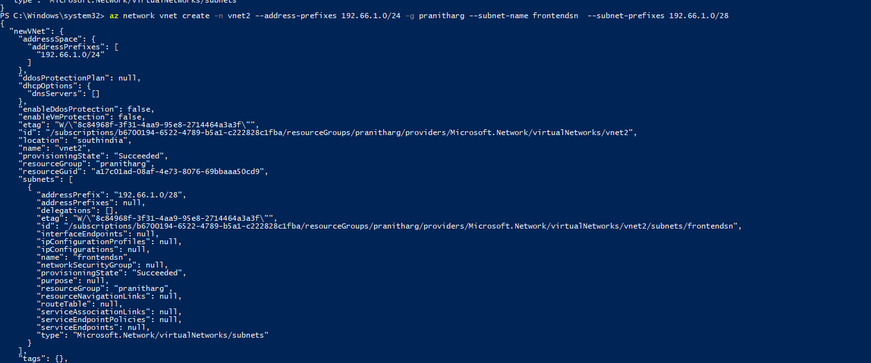

2.Create backend subnet for vnet1

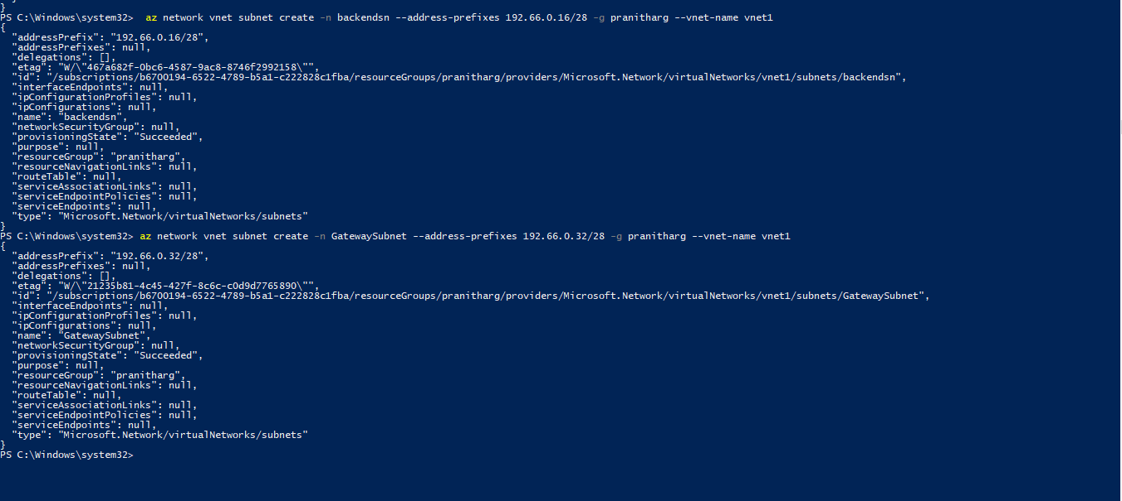

3.Create gateway subnet for vnet1

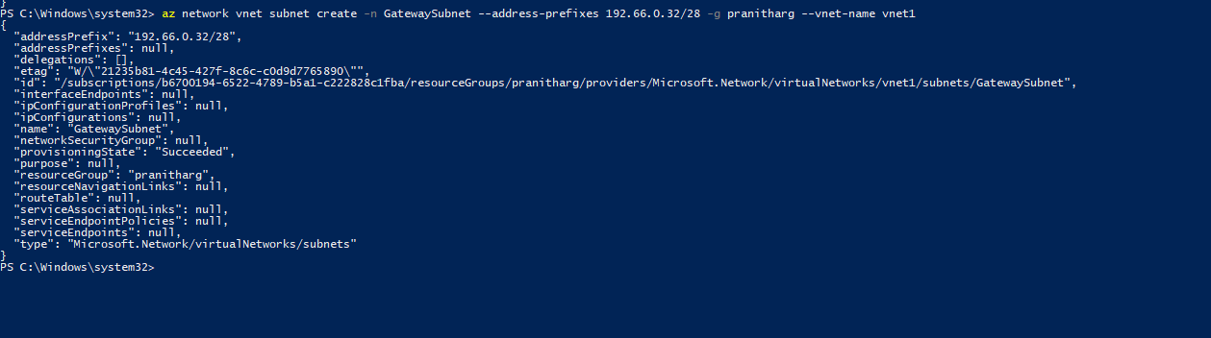

4.create frontend subnet for vnet2



5.create backend subnet for vnet2

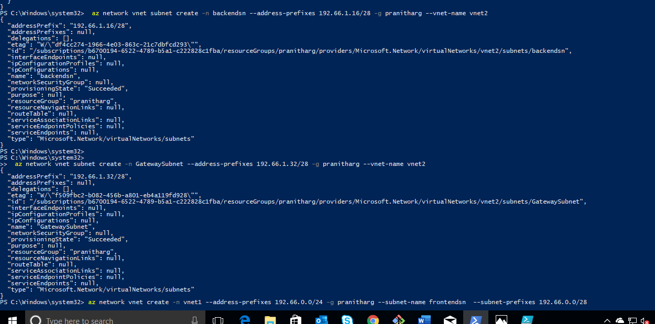

6.create gateway subnet for vnet2

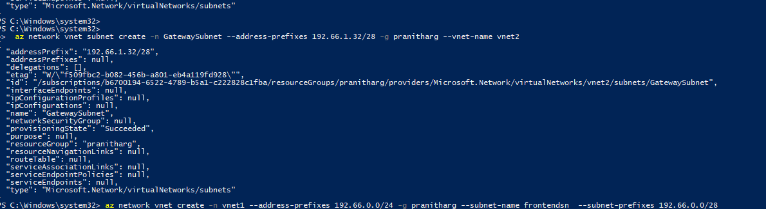

7.create frontend subnet for vnet3

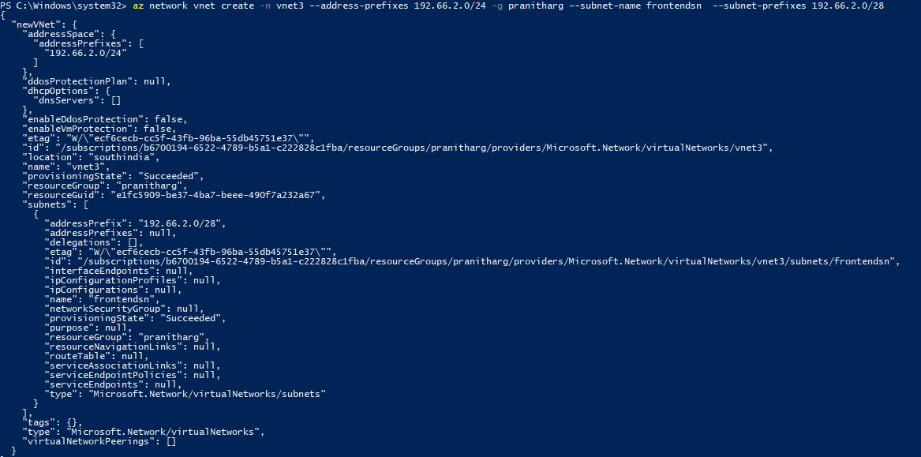

8.create backend subnet for vnet3

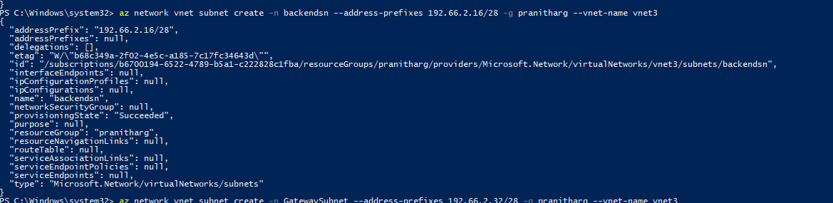

9.create gateway subnet for vnet3

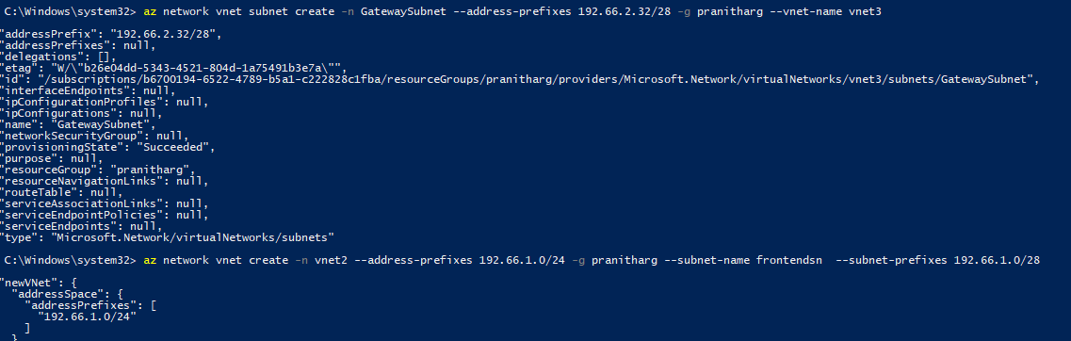

10.create vpn gateway for vnet1

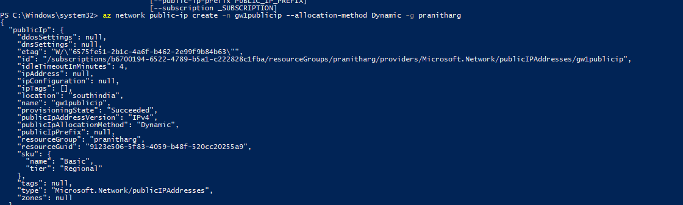



11.create vpn gateway for vnet2

